Basic Git workflow for setting up a new Project on GitHub

**PURPOSE OF THE DOCUMENT**

This document describes the process of creating a new project on GitHub and setting up Git on a local computer to be able to perform git related tasks on the project.

**AUDIENCE**

This document is intended for students in the software domain involved in creating and reviewing projects on GitHub.

**SCOPE/OBJECTIVES**

The document covers the process for creating a new project on GitHub and setting up Git on local computer to link with the GitHub project. The scope can be broken down into following objectives:

1. Creating a new account on [GitHub](https://github.com/).
2. Starting a new project on GitHub.
3. Installing git on local computer.
4. Using git to update a document on local computer
5. Linking a local folder to project on GitHub using Git.
6. Moving all the changes from local git to GitHub project.

**EXECUTION STEPS**

**Step 1: Creating a new account on GitHub:**

* Visit <https://github.com/> in your browser.
* Search for “Sign Up” option (Should be on the top-right corner) and click on it.
* Once the Sign-Up page is visible, it will ask for username, email and password. Enter the email that can be used to verify the GitHub account.

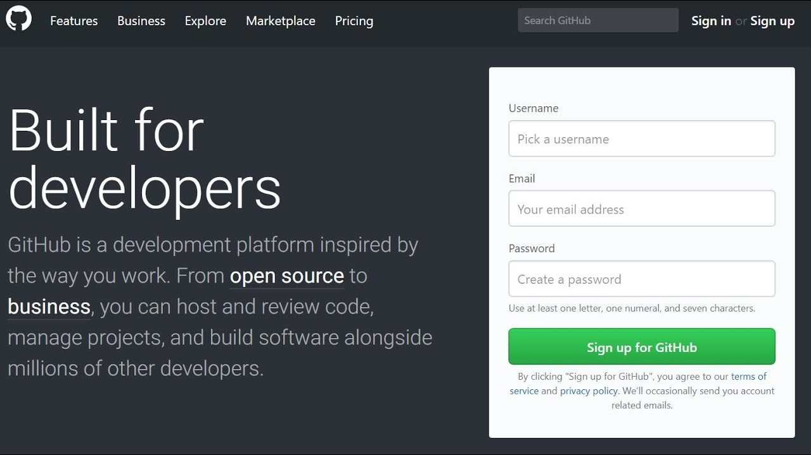

* Fill in the password and username in the Sign-Up form to complete creating a new account
* GitHub may ask for verification of the email used to create the account by sending a code to the registered email.
* After the account is ready for use, GitHub should be logged in with the new account.

.

**Step 2: Starting a new project on GitHub:**

* Find option on GitHub dashboard to create a new project. (The plus + icon on top-right corner has the option for “New Repository”)

* A form to create a new project will open.
* Type in a Repository Name to be used for the project. Keep all other options in the form as default and there is no need to update any field.

**Step 3: Installing git on local computer:**

* Go to link(<https://gitforwindows.org/>) and click on the “Download” option to start downloading the setup file for Windows.
* Once the download is finished, Locate the downloaded file on the local computer(within the Downloads folder) and open it by double clicking on the file.
* A setup dialog for installation should appear. Follow the instructions to finish the installation.

**Step 4: Using git to update a document on local computer:**

* Locate the folder which needs to be added to the git project
* Open terminal and change the current directory in terminal to the document folder using command > *cd <directory-location>*

* Now use the following git command to initialize the folder as a local git project *> git init* .
* Make the changes within the folder and after they are ready to be added to the GitHub project, use following commands to stage the changes and save the snapshot to be pushed to the GitHub project:
  + Stage Changes: *git add .*
  + Save/ Commit with a message to explain the changes: *git commit -m "Adding exercise file with git related text changes"*
* Rolling back any changes in git
  + Use the command *git log* to see the history of changes being made to the local project.

* + To roll back any changes, copy the commit ID highlighted in the *git log* output and use the command *git revert <commit-ID>* to undo the specific changes.
  + If the terminal opens a file after running the *git revert* command, use the following key sequence to close the file :
    - Press the “Esc” key on keyboard to switch mode.
    - Type the following characters (*:wq!*) and Press Enter to close the file

**Step 5: Linking a local folder to project on GitHub using Git:**

* With the terminal on the git project directory, use git remote command to link the local git folder to the GitHub project link: *git remote set-url origin <github project-link>*



**Step 6: Moving all the changes from local git to GitHub project:**

* Use git push command from the terminal to push changes from local git to the GitHub project : *git push -u origin master*. The master refers to the branch of the git project.
* At this point, git may ask to set up user for the account being used to push changes to the GitHub project over the terminal.
  + Use the same email as GitHub account to login into git for the local computer
  + When asked for password, create an access token using the settings from GitHub (<https://github.com/settings/tokens>). Make sure to Add a note to the token being generated to distinguish between tokens for different purposes. For the option of expiration time, select a duration suitable for use case such as 1 year. It is preferred not to create a token without an expiration date to avoid being misused.

* + Enter the token as password.
  + After the email and tokens are validated, the changes from local git should be pushed to the GitHub project.

**REVISION HISTORY**

|  |  |  |  |
| --- | --- | --- | --- |
| **Version** | **Date** | **Changes Made By** | **Summary of Changes** |
| 1.0 | *24-01-08* | Lu Liu (luliu@student.mitt.ca) | Initial Process Document for GitHub |
| 1.1 | *24-02-12* | Yang Zhao (yangzhao@student.mitt.ca) | Revised with comments for readability and clear understanding of instructions |
| 1.2 | *24-02-12* | Lu Liu (luliu@student.mitt.ca) | Final Document based on the content review |

**Assignment Submission Information**

**Step 1:**

**GitHub Repository Link :** <https://github.com/LL-fullstack/sample-text-project>

**Classmate Changes to exercise.txt file in Repository :**

<https://github.com/LL-fullstack/sample-text-project/commit/9b1760f50141b59078608b6095420a656d2456ab>

**Step 2:**

**Review comments and Feedback on Process document from classmate :** <https://github.com/LL-fullstack/sample-text-project/commit/a5951b476c3430c39e89227e286ae73ee733f6a8#commitcomment-138543393>

**Step 3:**

**Brief Summary of changes to GitHub file :**

**Link :**

<https://github.com/LL-fullstack/sample-text-project/commit/9b1760f50141b59078608b6095420a656d2456ab>

**Summary:**

The exercise.txt file contains a step-by-step sequence of commands to rollback changes committed to the project. In the original content, the steps consisted of following actions :

Log the history of commits -> **Revert the commit-id of changes** -> Check the status after rollback.

The reviewer suggested introducing an additional step of checking the logs after performing the revert action to make sure that the commits are in sequence and there is a new commit-ID added for the revert action.

**Brief Summary of changes to Process Document :**

**Comments Link :**

<https://github.com/LL-fullstack/sample-text-project/commit/a5951b476c3430c39e89227e286ae73ee733f6a8#commitcomment-138543393>

**Summary :**

The process document had following changes after review :

* Simplifying instructions by using direct statement such as "*Visit github.com in your web browser.*" Instead of “*Click on the link (*[*https://github.com/*](https://github.com/)*) to open the GitHub website in a browser.*” which may confuse audience if the document link is not working in their local computer.
* One of the instructions in Step 2 had multiple actions combined in a single statement which may make it difficult to follow.
* While it is essential to specify the instructions clearly, one of the actions had some context as to which option to choose and without mentioning the reason behind the selection, the audience may not understand the future consequences if something goes wrong.

**GitHub Content**